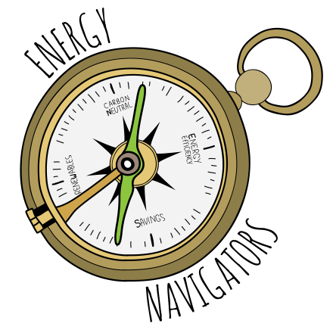

Energy Navigator Volunteer

Job Description
Title
Energy Navigator Volunteer

Description
Energy Navigators are concerned and capable residents who help their friends, neighbors and other community members learn about ways they can reduce their energy use and energy bills and use renewable forms of energy to heat and power their homes. In particular, Navigators focus on programs that cover costs of energy efficiency, renewable heating and solar for households with limited income. Navigators provide one-on-one advising to interested residents, including doing walkthrough home visits with hands-on demonstrations of energy-saving strategies. They also try to lead by example!

Responsibilities
Over a period of twelve months, Energy Navigators help at least 10 residents take concrete steps to reduce energy use, save money and switch to renewables. To accomplish this goal, Energy Navigators are expected to do the following:
- Participate actively in all sessions of the training, including completing homework when necessary.
- Volunteer for at least 60 hours over the course of their service period which could include helping staff a table at community gatherings or festivals, giving community presentations, or accompanying staff or experienced Navigators on a home visit.
- Actively seek out people who are interested in reducing their energy use and carbon emissions, especially those with limited income. This can be done in a number of ways, including personal networks and public outreach.
- Follow up with those who express interest, including contacts assigned by staff, in person, via email or phone, within a few days, and track these interactions using an online tracking tool.
- Create work plans with the support of CCE staff, and provide updates at month meetings as needed.
- Participate in monthly Energy Navigator Volunteer meetings or gatherings that follow the period of training.

After the period of their service, interested Navigators can continue their volunteer work with varying levels of involvement.

Energy Navigators Volunteers are also expected to:
- Represent at all times the high standards of Cornell Cooperative Extension.
- Only disseminate unbiased, research-based information.
- Help improve the Energy Navigator Volunteer program by providing regular feedback.

Expected Results
By applying their training to their own situation and helping other people, Energy Navigator Volunteers actively promote energy efficiency and renewables, and help North Country residents achieve greater comfort, energy savings, and move the community towards carbon neutrality by 2030.

Qualifications
- Basic interest in energy-related knowledge and skills.
- Enthusiasm for helping others with energy-related questions and actions.
- Reside in the North Country, or be well-connected to the area.
- Ability to attend all training sessions and commitment to do related service work.
- Ability to use the internet to conduct research required to answer basic energy questions with unbiased information.
- Ability to communicate with community members in a responsible, helpful, timely, and respectful fashion.
- Ability to self-start and follow through on volunteer efforts with limited guidance.

Benefits
- Acquire new knowledge and skills.
- Reduce energy waste and help community members save money, and have more comfortable homes.
- Contribute to reduced greenhouse gas emissions.
- Improve teaching and leadership skills through community education.
- Make a difference in people’s lives through community service.
- Meet new people, and work as a team with others who share similar interests

Training
Eight 2-hour sessions. Classes are a mix of classroom presentations and discussions, led by Cooperative Extension educators and community specialists, at least one session will be in-person. Topics include energy efficiency, renewables, heating systems, energy audits, as well as outreach and community-building skills. Topics of transportation, waste reduction and local food will be treated in brief. Some sessions require up to a few hours of homework to fully benefit from the in-person training.

Following the training, there will be monthly Navigator meetings to share updates, receive support, provide additional training, and enjoy each other’s company.

Level of Background Screening Required
As part of the Cooperative Extension system, volunteers are screened in several ways:
- Application and reference checks
- NYS Sex Offenders Registry & National Criminal History check (which requires providing a social security #)

Questions?
Contact Nick Hamilton-Honey, North Country Energy Navigator Volunteer Coordinator, nh327@cornell.edu or 315-379-9192 x 230.

Energy Navigators is a program of Get Your GreenBack Tompkins,
with the support of Cornell Cooperative Extension of Tompkins County

