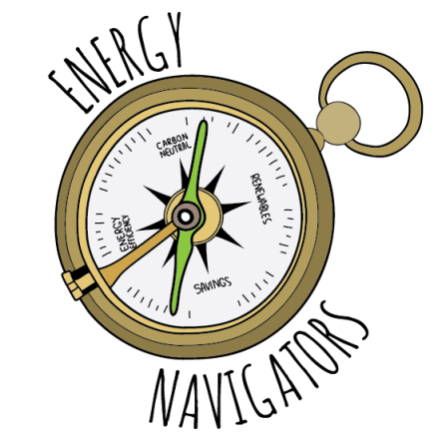
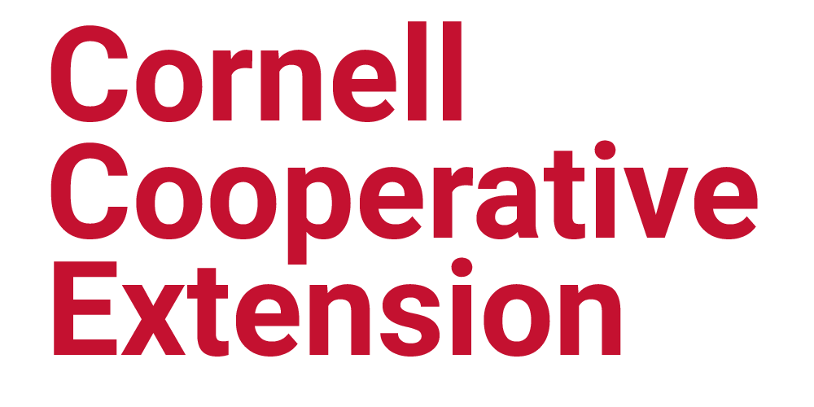

Energy Navigator Volunteer Application
Energy Navigators are concerned and capable residents who help their friends, neighbors and other community members learn about ways they can reduce their energy use and energy bills and use renewable forms of energy to heat and power their homes. They also try to lead by example!

Energy Navigators commit to a year-long program that includes a period of training, followed by supervised outreach and education with community members. Volunteers are expected to give at least 60 hours of their time over the course of the year to related outreach activities, and help at least ten of their contacts with energy-related actions (please read the Volunteer Job Description for more information on expectations).

Energy Navigator trainee selection is based on an applicant’s ability to attend the training sessions, and their capacity and interest in helping others. Preference is given to volunteers who are connected to diverse populations in rural and urban areas.

The 9-session + Introduction Energy Navigator Training will begin on a rotating basis. After the training, monthly gatherings will be held to support Navigator outreach activities, and share additional information.

Application Deadline: None currently. Applications are accepted when they are submitted.

Return to: Cornell Cooperative Extension of St. Lawrence County, 2043B State Highway 68, Canton, NY 13617

Questions? Contact Nick Hamilton-Honey, North County Energy Navigator Volunteer Coordinator, nh327@cornell.edu or 413-885-5725 cell.

Date of Application: ____________________________ Do you Rent or Own: ________________

Name: _________________________________________________________________________

Phone(s): _____________________________________ Email: ____________________________

Preferred Communication Method (Circle One): Email Phone Text
Birthdate if under 18: _____________________________________________________________

Resident of which County: Clinton____ Essex____ Franklin____ Hamilton____ Jefferson____ Lewis____ St. Lawrence____

If a response requires more space than is provided, feel free to use additional paper.
1. Why do you wish to become an Energy Navigator? (Why is it a good fit for you?)

2. What skills and experience do you bring that will help you be a successful Energy Navigator and/or a resource to other volunteers? (e.g. experience with community outreach, diverse community contacts and networks, relevant studies or work experience in energy fields, first-hand experience with energy efficiency or heating, etc.)

3. Which of the following things are you doing/have done or would like to do? Mark all that apply.

 | Am Doing / Have Done | Would Like to Do | Not Now
Energy audit on home
Air sealed & insulated home
Solar electric (PV) or solar hot water
Heat with wood or wood pellets
Heat with heat pumps (air-source or “geothermal”)
Drive an electric vehicle or a hybrid
Other:

4. On a personal level, if the program could help you with one energy improvement, what would it be?

5. Check (√) three of the following Energy Navigator training topics that most interest you.
___ Home Energy Use – Understanding Utility Bills
___ Energy Efficient Homes – Energy Audits – DIY vs. Contractor
___ Electricity, Lighting & Appliances
___ “Smart” Meters, Thermostats, Power Strips & other Appliances, Time of Use Rates
___ Heating Systems
___ Solar Power & Renewable Energy
___ Electric Vehicles & Sustainable Transportation
___ Local Food & Waste Reduction
___ Trust, Relationship Building & Community Outreach
___ Climate Change & Our Carbon Footprint
___ Other: __________________________________________________________________

6. Have you ever volunteered/worked for Cooperative Extension before: ___Yes ___No
If yes, give dates, program position, County/State

7. Check (√) two of the following volunteer activities that most interest you. While everyone is expected to help at least two of their contacts with energy-related decisions, there will be other opportunities for volunteering. Your answer will give us a sense of the type of activities you are most interested in.
___ Informal conversations with friends, family and neighbors on energy-related choices
___ Presentations to community groups on energy-related issues and local resources available
___ Following up in person or over the phone with people who request energy advising
___ "Tabling" and engaging with people at community events and festivals
___ Answering questions via email or on the phone
___ Updating/developing factsheets or program resources, website, articles, social media, etc.

Which one of these would be your top choice? ___________________________________
Comments (optional):

8. Approximately how many hours per week do you anticipate volunteering? _______________

9. Where did you learn about the opportunity to volunteer as an Energy Navigator?

10. Would you be willing to host a training session or gathering at your home? Marking "yes" is not a commitment, but lets me know it may be a possibility. Homes with renewable heating systems, solar, or other relevant characteristics are useful for the group's learning.
___ Yes ___ No
If ‘yes’, please describe what might be useful about using your home.

11. Do you anticipate having any trouble with transportation?
___ Yes ___ No
If ‘yes’, please describe.

12. Do you have any physical or health accommodations that may be needed to allow you to participate fully in Energy Navigator training and/or volunteering?
___ Yes ___ No
If ‘yes’, please describe.

13. Do you now have, or anticipate, any obligations that may prevent you from fulfilling the volunteer commitment to the Program over the next year? ___ Yes ___ No
If ‘yes’, please describe, this does not eliminate you from the program. CCE strives to accommodate our volunteers needs.

