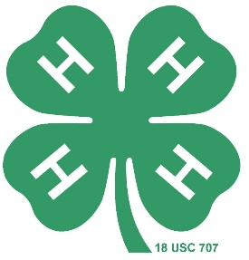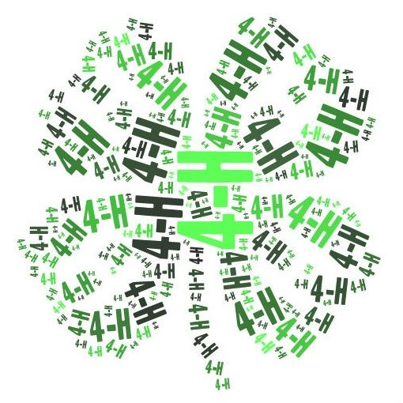

**St. Lawrence County**

4-H Project Record

and Achievement Report

Name: ­­­________________­­­­­­­­­­­­­­­­­­­__________________________

Name of Club: ___________________________________

Year: October 1, ________ - September 30, _________

**4-H Member’s Record** Years in 4-H ___­­___

Member’s Name:______________________________________________________________

Street Address:__________________________ City: _______________ Zip: ____________

Phone: _________________ Date of Birth: _____________ Age as of Jan. 1 ________

Name of Club ____________________________ Independent Member? Yes ___ No ____

Leader’s Name: _______________________________________ Years in 4-H: _________

Were you a club officer this year? If yes, what office did you hold? _____________________

Committees or other roles you served in your **4-H Club** this year:

____________________________________________________________________________

____________________________________________________________________________

____________________________________________________________________________

[photo here]

4-H Achievement Certificate Application

Due to 4-H Office by **the third Friday in September @ 3:30 p.m.**

4-H’ers must submit this form to their Club Leader for review and signature.

AWARD APPLYING FOR: (PLEASE CHECK)

|  |  |
| --- | --- |
|  | 1. Cloverbud (5-8 years of age) |
|  | 2. Bronze (8 years of age & up) |
|  | 3. Silver (8 years of age & up) |
|  | 4. Gold (8 years of age & up) |
|  | 5. Emerald (13 years of age & up) |
|  | 6. Ruby (13 years of age & up) |
|  | 7. Pearl (16 years of age & up) |
|  | 8. Diamond (16 of age years & up ) |

**4-H’er & Leader/Parent Statement:**

I attest to best of my ability that this information provided in this packet is true and correct.

4-H Member’s Signature: _________________________________________

Club Leader’s Signature: _________________________________________

Parent’s Signature: _________________________________________

(Independent 4-H’ers Only)

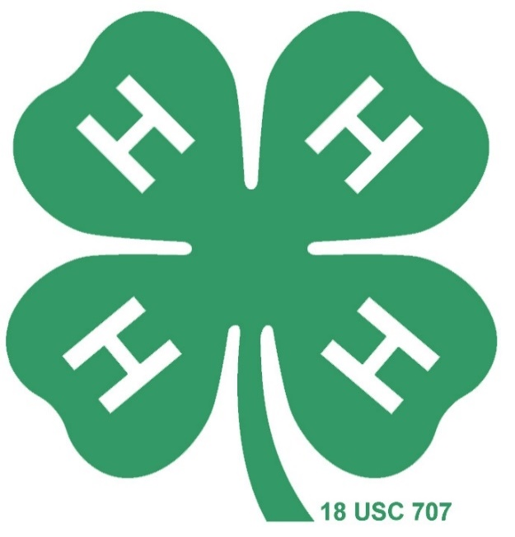

**4-H Achievement Certificate Guidelines**

**Levels & Requirements:**

**Cloverbuds (5-8 Years of Age):**

• 2 Cloverbud Projects

• 2 hours of Community Service

• 1 Educational Event

**Bronze (8 Years of Age & Up):**

• 2 Project

• 5 hours of Community Service

• 2 Educational Events

**Silver** **Certificate (8 Years of Age & Up):**

• 2 Projects

• 10 hours of Community Service

• 3 Educational Events

**Gold** **Certificate** **(8 Years of Age & Up):**

•  3 Projects

• 15 hours of Community Service

• 4 Educational Events

**Emerald Certificate** (**13 Years of Age & Up):**

• 4 Projects

• 15 hours of Community Service

• 4 Educational Events

• 2 Leadership Projects (with at least one being the primary leader of a club project)

• Promoted 4-H Club within the community

**Ruby Certificate** (**13 Years of Age & Up):**

• 3 Projects

• 15 hours of Community Service

• 4 Educational Events

• Lead a 4-H Project with **another** 4-H Club or organization

• 1 additional leadership project

• Promoted 4-H within the community by planning and implementing a club community service project

**Pearl** **Certificate (16 Years of Age & Up)**:

• 3 projects

• 10 hours of Community Service

• 2 Educational Events

• Lead a 4-H Project with **two** other 4-H Clubs and/or outside organization

• Developed a program or educational resource that will carry on or continue to be used in the future.

• Promote 4-H throughout St. Lawrence County

• Submit a proposed plan of work to the 4-H Youth Development Program no later than June of the 4-H year Continued on page 5

**Diamond** **Certificate (16 Years of Age & Up):**

• 3 projects

• 10 hours of Community Service

• 2 Educational Events

• Lead a 4-H Project with **two** other 4-H Clubs and/or outside organization

• Plan, promote, and implement a significant countywide community service project, in which other 4-H clubs or outside organizations would participate

• Promote the 4-H Club Program throughout St. Lawrence County

• Submit a proposed plan of work to the 4-H Youth Development Program no later than June of the 4-H year.

**Relevant Definitions:**

**4-H Age:** Your age as of January 1st of the 4-H year.

**4-H Project**: A unit of work, which may consist of a series of learning experiences, designed to help shape the character of 4-H youth and teach lifelong skills. You may request the 4-H Project List from the office to see examples available.

**4-H Cloverbud Project**: Similar to a 4-H project, however it is usually a short-term experience emphasizing socialization and involvement.

**4-H Educational Event**: An event that provides an added and unique educational experience. Examples include, but are not limited to the following:

Award Trips Educational Trips Officer’s Training

Achievement Day Activity Nights Dairy Bowl Contest

Public Presentations Clothing Review Dairy Judging Horse Communications Horse Bowl Livestock Clinics

County Fair Hammond Fair NYS Fair

Fundraising Projects 4-H Camp Overlook Dairy Camp

Showmanship Clinics 4-H SUNY Canton Vet Science Animal Nights

Farm Day Camp 4-H School Break Specials

**4-H Community Service**: Providing *assistance* that benefits someone outside of the member’s family and club.

**4-H Leadership Project**: Providing direction and guidance to others. Examples include, but are not limited to the following:

Serving as a Teen Evaluator at an Educational Event

Serving as a Teen Assistant/Leader/Superintendent at an Educational Event

Serving as an Officer in a 4-H Club or Teen Council

Leading a project within their 4-H Club or another 4-H Club

Assisting another project leader within their 4-H Club

Serving on a Cooperative Extension Advisory Committee

Serving as a 4-H Camp Overlook Counselor

**4-H Promotion**: Promote the names, mission, and ideals of the 4-H program by informing the community through advertising or publicity:

Lead the planning and operation of County Fair Club Booth or Activity booth

Write articles for Extension News and/or the public newspaper

Organize a booth, float, or group for Dairy Princess Parade

Plan and implement a Community Service project that educates the public about the 4-H program.

**Please Note:** Be careful not to use the same activity for credit in two separate categories.

Revised 09/24

**Project Report**

4-H Project and Description**:** ___________________________________________

____________________________________________ Years in project ­­­________

Talk about what you learned, what you would do differently next time.

__________________________________

__________________________________

__________________________________

__________________________________ [photo here]

__________________________________

__________________________________

__________________________________

__________________________________

__________________________________

4-H Project and Description**:** ___________________________________________

____________________________________________ Years in project ­­­________

Talk about what you learned, what you would do differently next time.

__________________________________

__________________________________

__________________________________

__________________________________

[photo here]

__________________________________

__________________________________

__________________________________

__________________________________

__________________________________

**Project Report**

4-H Project and Description**:** ___________________________________________

____________________________________________ Years in project ­­­________

Talk about what you learned, what you would do differently next time.

__________________________________

__________________________________

__________________________________

__________________________________ [photo here]

__________________________________

__________________________________

__________________________________

__________________________________

__________________________________

4-H Project and Description**:** ___________________________________________

____________________________________________ Years in project ­­­________

Talk about what you learned, what you would do differently next time.

__________________________________

__________________________________

__________________________________

__________________________________

[photo here]

__________________________________

__________________________________

__________________________________

__________________________________

__________________________________

|  |  |  |
| --- | --- | --- |
| 4-H Project | Date | What did you learn or do? |
| EX.  Hobby ceramics with 4-H club | October 24, 2024 | I learned how to clean the mold and to paint with detail. |
|  |  |  |
|  |  |  |
|  |  |  |
|  |  |  |
|  |  |  |
|  |  |  |
|  |  |  |
|  |  |  |
|  |  |  |
|  |  |  |
|  |  |  |
|  |  |  |
|  |  |  |
|  |  |  |

**Additional 4-H Projects**

|  |  |  |  |  |  |
| --- | --- | --- | --- | --- | --- |
| Community  Service Title | Date | Time | Hours | Location | Explain what you did |
| EX. Roadside Clean-Up | May 7, 2024 | 1-3 | 2 | Stone Valley Trails | Picked up trash from the trails and disposed of garbage and recyclable materials. |
|  |  |  |  |  |  |
|  |  |  |  |  |  |
|  |  |  |  |  |  |
|  |  |  |  |  |  |
|  |  |  |  |  |  |
|  |  |  |  |  |  |
|  |  |  |  |  |  |
|  |  |  |  |  |  |
|  |  |  |  |  |  |
|  |  |  |  |  |  |
|  |  |  |  |  |  |
|  |  |  |  |  |  |

**Community Service Hours Log**

**Total Community Service Hours ________­­­____**

|  |  |  |
| --- | --- | --- |
| Educational Event | Date | Explain what you did and what you learned |
| EX. Public Presentations | March 7, 2024 | I gave a public presentation about the importance of recycling and I learned that speaking in front of others can be fun. |
|  |  |  |
|  |  |  |
|  |  |  |
|  |  |  |
|  |  |  |

**Educational Events**

|  |  |  |
| --- | --- | --- |
| Leadership Project | Date | Explain what you did to lead the project |
| EX.  Cooking with Cloverbuds | April 15, 2015 | I found easy recipes to do with cloverbuds, bought the ingredients, prepared the materials, taught the cloverbuds basic baking information, and helped them make brownies. |
|  |  |  |
|  |  |  |
|  |  |  |

**Leadership Projects**

Did you lead a 4-H Project with **another** 4-H Club or organization? (Ruby, Pearl, Diamond)

Club or organization name: 1. __________________________________________

2. __________________________________________

**4-H Promotion Project**

|  |  |  |
| --- | --- | --- |
| 4-H Promotion | Date | Explain what you did to organize the project |
| EX.  4-H Activity Booth at  County Fair Youth Building | June 6, 2015 | I organized an action booth for the County Fair Youth Building by reserving the location, planning activities for families, recruiting volunteers to help, and running the booth. |
|  |  |  |
|  |  |  |
|  |  |  |

**Additional Information**

Did you give a Public Presentation? Club ____ County ____ District ____ State ____

Horse Communication? Club ____ County ____ Regionals ____ State ____

Other _____________________

Title and type of Presentation: ___________________________________________

Did you exhibit at the County Fair? Yes _____ No ____ State Fair? Yes ____ No ____

List your county fair exhibits ____________________________________________________

____________________________________________________________________________

____________________________________________________________________________

____________________________________________________________________________

List your state fair exhibits ________________________________________________­­­_____

____________________________________________________________________________

List any special awards received in any 4-H event this year: (i.e. contest placings,

­­­­­­­____________________________________________________________________________

____________________________________________________________________________

____________________________________________________________________________