4-H Achievement Certificate Application
Due to 4-H Office by the third Friday in September @ 3:30pm
4-H’ers must submit this form to their Club Leader for review and signature.
Name:
Address:
Phone: |  |  | Age: |  |  | Date of Birth:
4-H Club: |  |  |  |  |  | Year in School:
Years as a Cloverbud: |  |  |  | Years in 4-H:

AWARD APPLYING FOR: (PLEASE CHECK ✓)
1. Cloverbud (5-8 years of age)
2. Bronze (8 years of age & up)
3. Silver (8 years of age & up)
4. Gold (8 years of age & up)
5. Emerald (13 years of age & up)
6. Ruby (13 years of age & up)
7. Pearl (16 years of age & up)
8. Diamond (16 of age years & up )
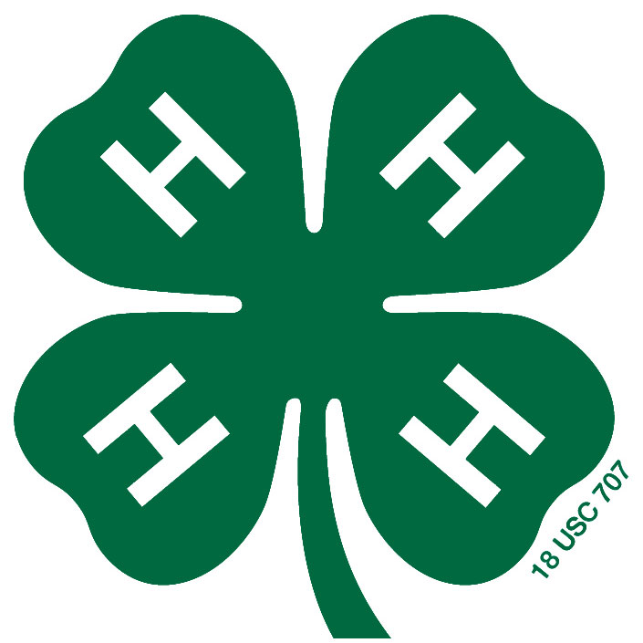
Was a project record book submitted to your club leader and 4-H Office? _____ Yes _____ No

Did you complete the minimum number of projects required for this award? _____ Yes _____ No
Please list below:

Did you complete the minimum hours of community service? _____ Yes _____ No
Please list below:

Did you attend the minimum number of educational events? _____ Yes _____ No
Please list below:

EMERALD & UP: Did you complete the minimum number
of leadership projects? Please list below: _____ N/A _____ Yes _____ No

RUBY ONLY: Did you plan, promote and implement
a club community service project? Describe below: _____ N/A _____ Yes _____ No

PEARL ONLY: Did you develop a program or educational
resource? List title below and include description in your
permanent record. _____ N/A _____ Yes _____ No

DIAMOND ONLY: Did you plan, promote and implement
a significant countywide community service project? List title
below and include description in your permanent record. _____ N/A _____ Yes _____ No

4-H’er & Leader/Parent Statement: I attest to best of my ability that this information is true and correct.

4-H Member’s Signature: _________________________________________

Club Leader’s Signature: _________________________________________

Parent’s Signature: _________________________________________
(Independent 4-H’ers Only)

