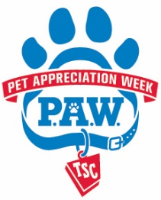
October Club News
Tractor Supply Company Pet Appreciate Week: Many 4-H clubs and volunteers when out to local Tractor Supply stores to promote the 4-H program. Thank you to all 4-H members and volunteers who participated and set up at local stores, and thank you to everyone who donated!! Your support and dedication is greatly appreciated!
Year End Celebration: Extension will be hosting the Year End Celebration this year on October 23th at 6pm at the Hermon DeKalb School. There will be a pot-luck dinner so all families are encouraged to bring a dish to pass. Following the dinner will be awards and recognitions for both 4-H members and volunteers. The evening will finish off with activities and games including robotics demonstration, pumpkin crafts, and an optional costume contest. 4-H members who are applying for awards should have their applications submitted into the Extension Office no later than October 16th. Applications received after this date will not be accepted. The Achievement applications can be found on the Extension website at http://stlawrence.cce.cornell.edu/4-h/club-news-and-information.
New 4-H STEAM Club: A new 4-H club is forming in the Gouverneur area and will be focusing its interest on S.T.E.A.M. activities and is looking for members. S.T.E.A.M stands for Science, Technology, Engineering, Art & Design and Math. These are important skills that can help our young people prepare for the jobs of tomorrow. The group's focus will be on S.T.E.A.M. activities but will not be limited to them. We hope to have our first meeting in the first week of November. Meetings will be held after school hours. Please contact Mindy Wickham at 315-766-6682 or mindywickham@live.com or on facebook: Mindy DeGroot Wickham for more details.
4-H, Food, and Fun: Extension Staff will be organizing a fun and nutritious event of food preparation and tasting for 4-H members and families on Saturday November 7th from 10am-1pm. Participants will be asked to prepare a dish on site in the categories of appetizers/snacks, main dish/ sides, desserts. There will not be stoves or ovens, only a microwave, an electric frying pan, and electric stove plates. Participants can bring electric table top griddles, hot plates, microwave etc. if they so choose. Some ingredients that need to be cooked before-hand such as pasta, meats, etc. can be cooked prior to the event, but the bulk of the food dish should be prepared and assembled by the 4-H’er at the event.
Participants are asked to try and prepare a healthy recipe, or to adapt a pre-existing recipe to make it healthier by substituting healthy alternative ingredients. Participants will have 2 hours to prepare their recipe, and at noon all dishes will be available for taste testing by all participants and families, and will be voted on for their favorite recipe. Participants are asked to provide copies of their recipe and to write a brief explanation of how the recipe is healthy, or how they modified an old recipe to make it healthier. For more information please contact Cassondra Caswell at 315-379-9192 x235. Please call the office to sign-up by October 30th.
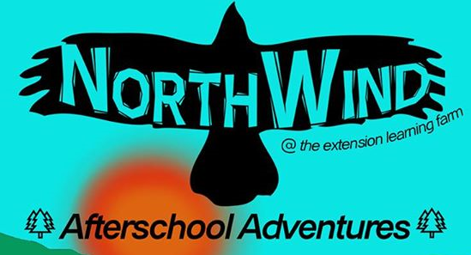
North Wind Afterschool: We are excited to announce the opening of a brand new after school enrichment program at the Cornell Cooperative Extension Learning Farm. This program targets youth from kindergarten through sixth grade and weaves together homework assistance with agriculture education, team building, and skill development based around STEM principals. Youth attending the program will focus on learning by doing through activities such as snowshoeing through the woods to identify animal tracks, collecting maple sap and boiling it to make syrup, and hatching chickens, turkeys, and guinea hens through an embryology project. Participating youth will become Junior Master Gardeners and Junior Ornithologists. Registration is open now! Registration packets are available at Cornell Cooperative Extension 2043B State Highway 68, Canton NY 13617 or by calling (315) 379-9192.

